TITLE OF PAPER FOR CONFERENCE GOES HERE

[TIMES NEW ROMAN, SIZE 12, BOLD, centred]

(this template must not contain author’s personal information)

ABSTRACT [Font: Times New Roman, size 11, italic, justify]
Abstracts should be written in English and should contain approximately 300 words. Abstracts should contain a clear indication of the purpose of the research, the approach used, the major results and the implications to be described in the full paper.

Keywords: Keyword1, Keyword2, Keyword3,... (in Alphabetical order [Font: Times New Roman, size 11, italic]) max. 6 words!

The paper must be formatted on B5 JIS paper – with the following margins: left and right: 2,5 cm top: 1,75 cm; bottom: 1,25 cm.

Do not add page numbering.

The maximum number of pages is 30!!

1 INTRODUCTION [FONT: TIMES NEW ROMAN, SIZE 11, BOLD, justify]
Body text goes here, Body text goes here, Body text goes here, Body text goes here, Body text goes here, Body text goes here, text goes here Body text goes here. [Font: Times New Roman, size 11]

2 CHAPTER [FONT: TIMES NEW ROMAN, SIZE 11, BOLD, justify]
Body text goes here, Body text goes here, Body text goes here, Body text goes here, Body text goes here, Body text goes here, Body text goes here, Body text goes here, Body text goes here (Tanzi and Schuknecht 2000). [Font: Times New Roman, size 11]

2.1. Subchapter title [Font: Times New Roman, size 11, bold, justify]
Body text goes here, Body text goes here, Body text goes here, Body text goes here, Body text goes here, Body text goes here, Body text goes here (Baltagi, 2008).

2.1.1 Subchapter title [Font: Times New Roman, size 11, bold, justify]
Body text goes here, Body text goes here, Body text goes here, Body text goes here, Body text goes here, Body text goes here, Body text goes here, Body text goes here, Body text goes here.

Figure/Chart 1. Figure/Chart title (source) [Font: Times New Roman, size 11, italic, centred];

PLEASE DO NOT USE COLOR!

Example:
Figure 1. Expenditure on public education in EU 27, Japan, USA and Canada in the period from 2002 to 2011 (in % of GDP)
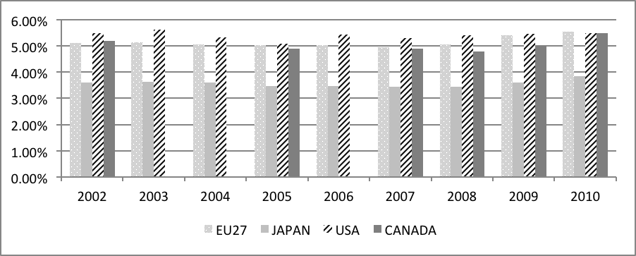
Source: OECD 2013. Education at a Glance; European Commission 2013. Taxation trends in the European Union

Table 1. Table title (source) [Font: Times New Roman, size 11, italic, centred] PLEASE DO NOT USE COLOR!

Example:
Table 1. Empirical versions of Wagner’s Law
No. | Function of form | Version
1 | GE = ƒ (GDP) | Peacock and Wiseman (1961)
2 | GC = ƒ (GDP) | Pryor (1968)
3 | GE = ƒ (GDP/N) | Goffman (1968)
4 | (GE/GDP) = ƒ (GDP/N) | Musgrave (1969)
5 | (GE/N) = ƒ (GDP/N) | Gupta (1967)
6 | (GE/GDP) = ƒ (GDP) | Modified P-W (1967)  version modified by Mann (1980)
7 | (GE/GDP) = ƒ ((GDP/N) + (BDef/GDP)) | Murty (1994)
Notes: GE = total government expenditure, GDP = gross domestic product, GC = government consumption expenditure, N = population, GDP/N = GDP per capita, G/N = total government expenditures per capita, GE/GDP = ratio of total government expenditures to GDP and BDef/GDP = ratio of budget deficit to GDP. [Font: Times New Roman, size 9, italic]
Source: Authors.

Table 2. The number of educational institutions in the Republic of Croatia in the period from 2002 to 2011
Year | Kindergartens | Elementary  school | High  school
2002./2003. | 1.067 | 2.139 | 650
2003./2004. | 1.067 | 2.138 | 665
2004./2005. | 1.190 | 2.141 | 665
2005./2006 | 1.205 | 2.140 | 683
2006./2007. | 1.244 | 2.146 | 705
2007./2008. | 1.288 | 2.133 | 710
2008./2009. | 1.325 | 2.127 | 713
2009./2010. | 1.444 | 2.131 | 713
2010./2011. | 1.495 | 2.130 | 711
2011./2012. | 1.514 | 2.136 | 715
Source: Ministry of Science and Education, 2013.

3 CHAPTER [FONT: TIMES NEW ROMAN, SIZE 11, BOLD, justify]
.
.

4 CONCLUSION [FONT: TIMES NEW ROMAN, SIZE 11, BOLD, justify]

5 BIBLIOGRAPHY [Font: Times New Roman, size 10, justify]

Bibliography must be listed as an autonomous final chapter at the end of your paper.

Please use the HARVARD STYLE REFERENCING.

Bibliography should be numbered and listed in alphabetical order.

Example:

1. Arnsperger, C. and Varoufakis, Y., 2006. What is Neoclassical Economics? [online]. Available at: http://www.paecon.net/PAEReview/issue38/Arnsper- gerVaroufakis38.htm.
2. Baltagi, B. H., 2008. Econometric Analysis of Panel Data. West Sussex: JohnWiley&Sons.
3. Brender, A. and Drazen, A., 2009. How do Budget Deficits and Economic Growth Affect Reelection Prospects? Evidence from a Large Panel of Countries. American Economic Review, 98(5), pp. 2203-2220.
4. Müeller, D.C., 2003. Public Choice III, Cambrige University Press, Cambrige.
.
.
.

